Missions History

MISSION FESTIVAL: Mission Festival was first celebrated in September 1892 and continues to be held. The occasion in early years featured three services: A morning service followed by a dinner and a social prior to the afternoon service and then an evening service. At present a service with a guest preacher, usually a missionary, is held. A meal would follow.
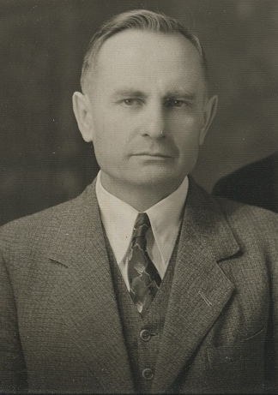
THE APACHE MISSION: In the fall a monetary donation is made to the Apache Mission in memory of Henry Rosin’s work there. Henry Rosin was born in 1892 in Wrightstown. He attended Northwestern College and Wisconsin Lutheran Seminary. His first call was to teach at the Indian Mission School in Globe, Arizona. In April 1918 he was called to fill the vacancy at the Peridot Mission where he taught at the Indian Mission School which was begun in 1903 and preached at the Lutheran Mission Church, the oldest on the reservation. Pastor Rosin served at Peridot for 50 years until his retirement in 1968. The Apache Mission celebrated its 125th anniversary in 2018.
MISSION OFFERINGS: WELS congregations carry out the Great Commission both locally and by joining together as a synod to reach “all nations” by training, equipping, sending, and supporting workers. Wels Home Missions supports 130 congregations and 32 college campus ministries. WELS World Missions shares the Gospel with more than 200,000 people in over 50 foreign countries. Congregation Mission Offerings (CMOs) are the main source for funding synodical ministry.
MISSION TO THE CHILDREN: More than twenty years ago the extreme poverty suffered by children and youth living in northern Mexico touched the hearts of a few Christians living near the Mexican border south of Tucson, Arizona. They saw an opportunity to share food and the good news of the forgiveness of sins that comes through Jesus Christ our Savior.
In 1989, Mission to the Children started with a few bags of food delivered to one border town and over the years Mission to the Children volunteers were invited to visit and serve poor children in 13 Mexican towns and villages.
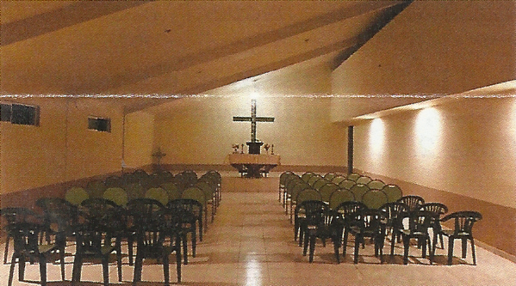
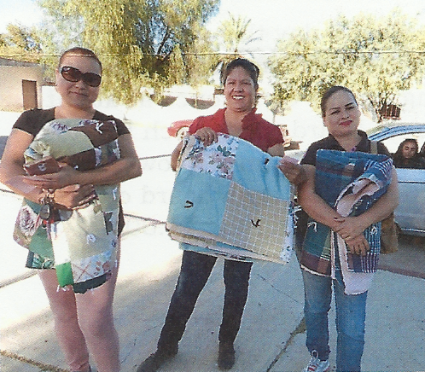
St. John congregation became involved at least 25 years ago. Donations of quilts from Martha’s Circle, supplies such as toiletries, socks, underwear, baby clothes as well as money would be sent to the MTTC volunteers who would take these supplies to Mexico.
Two of the villages now have churches with full time Iglesia Evangelica Luterano Confessional pastors (WELS is in fellowship with IELC churches). Besides food, Mission to the children assist with school supplies, vitamins and special needs medical services.
LUTHERAN WOMENS MISSIONARY SOCIETY (LWMS): The LWMS mission statement is: “LWMS is women dedicated to serving Jesus by increasing awareness of, interest in, and support of the mission outreach of the Wisconsin Evangelical Lutheran Synod (WELS).” We want to encourage women (and men) to learn about, pray for, and support with their offerings WELS mission efforts in North America and around the world. We have sisters and brothers in the faith in over 39 countries around the world beings served by WELS missionaries, going where we cannot go.
Members of St. John have attended LWMS conventions for about 25 years. Attendance at these conventions can range from 800 to 1600 women from across the country and around the world. Members return from conventions with renewed interest in sharing spiritual support, encouragement, and educating people about missions.

