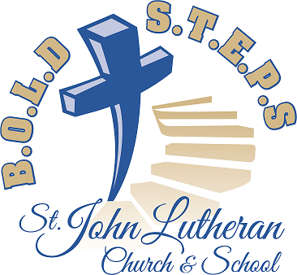
So now an exciting question arises: What from the present church should we incorporate into the planning for the new church? To help with that, we sincerely ask your input.

There are certainly many items/features of the present church which might be incorporated into the design of the new church. Some items might be left behind because of cost, others because of lack of interest. On the flip side is an initial list which we invite you to consider. Please rank each one on the provided scale, with ONE being a top priority and FIVE being a low priority for you.

Please note that this inquiry is general in nature. Ranking the organ ONE does not mean you want the whole organ in its present form to be moved to the new church. It's understood that alterations will be made to fit the size, architecture, and acoustics of the new setting. Similarly with the windows. Ranking them a high priority does not mean every window will go along with us. Rather, it means utilizing the windows or window elements in some way is important to you.

You may think of items not included in the list. We have included blanks for you to identify additional items.

Each communicant member is encouraged to submit a separate poll. Additional copies and a deposit box are in the entryway.

Possibly you will want to engage in a discussion with others within your family and beyond before each individually marking the ballot. Thanks for your input, and enjoy the process!

The survey is on the reverse side of this information sheet.

#7 June 2019
B.O.L.D S.T.E.P.S SURVEY

HIGH PRIORITY …...........LOW PRIORITY

ORGAN 1 2 3 4 5
WINDOWS 1 2 3 4 5
ALTAR 1 2 3 4 5
PULPIT 1 2 3 4 5
BAPTISMAL FONT 1 2 3 4 5
CHANDELIERS 1 2 3 4 5
PRESSED-TIN CEILING 1 2 3 4 5
PEWS 1 2 3 4 5
STEEPLE BELL 1 2 3 4 5
STEEPLE CLOCK 1 2 3 4 5
SLOPED FLOOR 1 2 3 4 5
HYMNBOARDS 1 2 3 4 5
KITCHEN CABINETS 1 2 3 4 5
____________________ 1 2 3 4 5
____________________ 1 2 3 4 5 #7 June 2019

