Memories of My Church and My School

Irma Scheibe (born 1916)
Remembers getting a new dress for Mission Festival

Walk to Wednesday evening services all alone; singing German hymns and hearing German sermons

Belonged to the Young People Society and went with them to pick out the chandeliers which are still in church.

Kermit Baumgartener (born 1932) Mission Festival
Recalls playing with the other children between services and then returning home in late afternoon to do milking and other chores before returning for the evening services.

Donald Wierschke (born 1921)
Recalls Saturday instruction classes taught by Pastor Uetzmann in the old German school

Men sat on one side of church, women sat on the other.

Pastor Struck used to go out the back door run around church, to sing in the choir.

Pastor Uetzmann
When a new church hymnal was introduced in 1941, much to the consternation of some church members, Pastor Uetzmann told members, “Don’t worry about it, just use it!”

Ken Wierschke (born 1937)
Sledding on the hill by the old school during recess.

Using the church bell as a school bell when we had school in the church basement

Played ball in the street.

Mission Festival where there were three services to make an all-day event. A very special occasion.

The church picnic at the end of the school year, before the school was out, at the village park.

Florence Wierschke (born 1905)
Sunday school memory verse cards

Penny collection

Wax candles on the Christmas Tree

Gas lights to electric lights; pump organ to pipe organ

Change from German to English

Alvin Zirbel (born 1913)
Sitting in 4th pew in front with step dad, Albert Timm, who was the janitor. He took up the penny collection alone every Sunday.

When old enough helped wind the clock and empty the ashes from the furnace.

Ellonora Haese Petersen (born 1923)
Remembers as a child, men sat on the left side in church. The women on the right. All the children sat with the mother.

There were 2 Christmas services. In the year 1933, Esther and I sang “Ihr Kinderlein Kommett” as the children marched in for Christmas Eve service.
Then in 1935, Evelyn Bohrtz and I sang it again as the children marched in.

Remembers when they took down the hitching post on the south side of church. They were located where the sidewalk is today.

Esther Krueger (born 1921)
Having a confession service before communion service

The services were in German; only special services where in English such as Christmas & Easter

Hearing Herman Roebke singing in German (Es ist noch Kaum) on Mission Festival Sundays.

Every Sunday we sang “All Glory be to God on High” and in German in the German service.

Being confirmed in 1934 with a class of 22 children, the largest class, in the history of St. John.

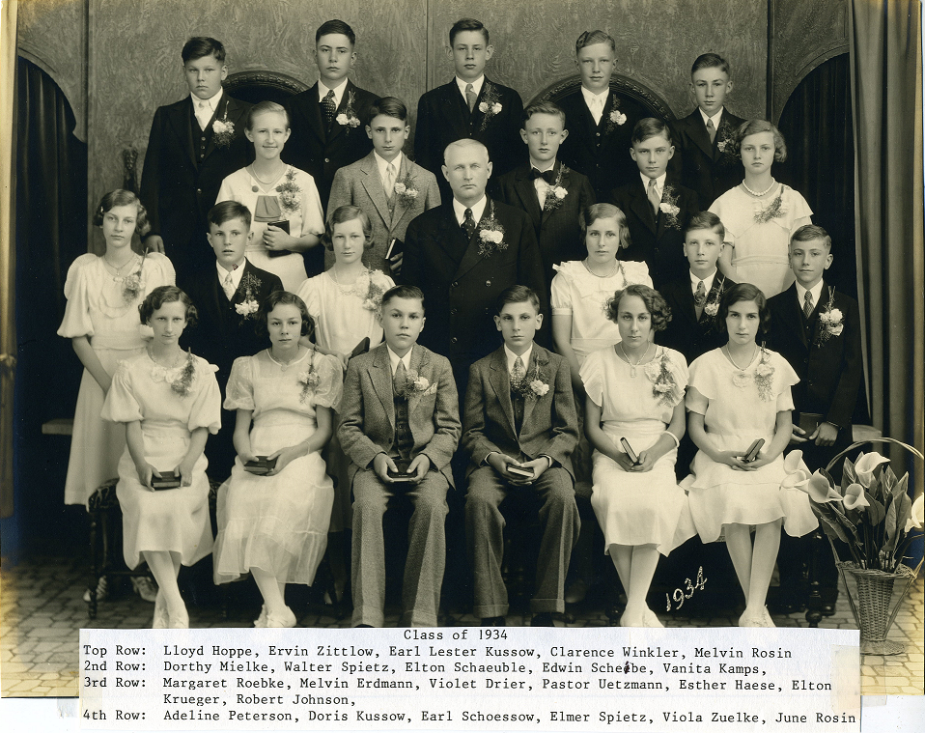

Raymond Zuelke (born 1900)
I remember when they moved the old church back and dug the basement with horses.

The old parsonage was moved across from church and a new house was built on the same place as the old.

Rev. Uetzmann came to visit by horse.

I also remember when my oldest sister died of typhoid fever and they brought her in the casket by sleigh into town.

Gloria Schroeder (born 1932)
Mom playing the organ

Going to German service with my grandfather

Mr. Koepsell. “He was a saint,”

Mr. Koepsell was very patient with all the students, made sure you understood the material being taught. And Gloria remembers him saying, “History equals ‘His story’ the story of Jesus.”

Lois Baumgartener (1937)
Mrs. Uetzmann’s beautiful flower garden that took up a large area behind church

Playing “work up” at recess in the big field of the “new” school – everyone participated (a form of baseball)

At age 5 or 6 standing below the pulpit singing “Jesus Loves Me” by myself.
Pastor Uetzmann had to prompt me to start singing.

The yellow brick school having a huge hill with pasture behind it. The school room only had a pot belly stove for heat during winter.

Allen Johns (1937)
During the winter when the school children, like himself, would be let out for recess—everyone would grab scoop shovels and slide down the big hill. Even the girls!

Then during the spring and summer months, baseball was played with EVERYONE. No matter what grade or gender you were. Trees, building corners, landmarks were the bases.

One year, Allen stated, “We played ‘King of the Hill’ on this gravel pile. Cannot remember why it was there, but we sure did have fun.”

Arlene Oakley (1937)
Mr. Koepsell stood out from the crowd. He taught 5th through 8th grade—all the subjects. Mr. Koepsell went the extra mile in his teaching.

Loree Baumgartener (1934)
As a teenager, I and Bob Brown ushered in church most Sundays

Mr. Draeger, Principal of school, and I waxed and cleaned school when I was on school board

Drove bus for school basketball teams

Plowed snow from church parking lot with a tractor and a bucket when the lot was still gravel – took turns doing this with Harry Bolssen

Jules Cappelle (2009)
Camp Phillip, VBS because it was fun

I like seeing the baptisms

I like the communions

I love going grandparent’s day

Cindy Ring (nee Baumgartener) (1960)
I remember my K-2 grade teacher, Miss Karen Jenkins, who inspired me to become a Lutheran grace school teacher. She had a wonderful smile, was very patient, and instilled in me a love or reading.

I remember my days at St. John’s fondly. I am thinking ful the teachers I had, Miss Jenkins, Miss Timm, and Mr. Draeger. They were wonderful examples of Christian teachers, dedicated to teaching me about my Savior.

Pastor Mike Gehl (1971)
Moving into the parsonage on one of the coldest days of winter and just after a big snowstorm. Moving van’s brakes froze up and driver asked if we had any alcohol. We did – in a packing carton – but it wasn’t of the isopropyl variety that he was looking for.

Being installed on the Sunday afternoon of Wild-Card Weekend. Prayed for a Packer first-round bye. Nope! Prayed for a Saturday game. Nope! Fantastic turnout of members, nonetheless!

Faye Patoka (1945)
When I started school I always looked forward to the Bible verse I would memorize.

The privilege of going to St. John Ev. Lutheran church and St. John Lutheran school to hear God’s word.

I enjoyed being in our mixed choir and ladies’ choir at church.

I enjoy the fellowship we have once a month since I’m retired and can go to Senior Lunch at church.

Jennifer Bunn (1976)
Most of my memories of St. John are school related since I have been a teacher here since 2001. I went to a Lutheran school like St. John in relation to size, type of building, and multiple grades. However, that school was in an urban setting and while we loved our pets, we did not love animals the way students at this rural school enjoy animals.
- During my first summer here, a future student stopped by my apartment to deliver a frog, a “really good” frog that he thought I’d enjoy.
- I had several students who were great at crayfish hunting and would often bring crayfish to live in our classroom aquarium. The preschool teacher at the time didn’t particularly care for them since some way, some how those crayfish, over the weekend, would make their way down to her classroom below mine. This happened more than one time.
- We have had several dogs and cats, and various other pets like chickens and lizards visit our classroom. I’ve had opportunity to bring all my pets, had students bring theirs for show and tell, and we even had dogs regularly come supervise recess and serve as reading buddies.
- My class won a contest over spirit week where I had to kiss a pig. Thankfully, it was a rather cute piglet.
- We’ve had several classroom pets including a deformed catfish who was caught from the Fox River. He survived in our small classroom tank for over three years. That same catfish literally ate our homework one evening. I had dropped off 30 feeder guppies in the tank one night to be used for the next day’s science lesson. I learned that channel catfish can eat a lot of guppies.
- One activity the students really enjoyed was watching and waiting for birds to hatch. Nothing else is happening in your classroom once birds start to hatch.
- We also had quite the variety of pets over the years including a parakeet, love birds, snails, hermit crabs, dwarf frogs, toads, insects and worms, butterflies and moths, a chinchilla, guinea pigs, a rabbit, and some other things I’m sure I’ve forgotten about.
- We have a very friendly rabbit that often roams freely. For those who’ve come into the school building not knowing this, he has popped up unexpectedly and caused quite a shock.
- We’ve had classroom pets die during the day on the last day before Christmas break twice. One of those passings came to my attention when one student let me know that our parakeet must be super tired because he is sleeping on the bottom of the cage. When I explained what had happened, he was super emotional and let me know that this was the worst Christmas ever.
- We had a horse visit the classroom one day. I was surprised that the horse made its way up the stairs and into he classroom. The kids were very amused when they found out the horse left a few “horse apples” in the hallway.
- One of my first home visits was to a family with several pets. The most notable being a very large rat. I was not sued to hanging out with very large rats.
- A herpetology club recently gave a classroom presentation in my grades 1-3 classroom. This presentation was extremely engaging since the husband/wife team that headed up this group were shockingly free with letting the lizards and very large snakes roam the classroom and slither all over the students. One student was a fan until a large one wrapped itself very tightly around his legs and his desk chair. The boy looked like he thought he was permanently attached to his desk chair. Another large snake somehow wedged itself into an opening for a handle on one student’s chair. It was so stuck that the presenters were a bit panicky and had us rushing around to try all manner of substances to safely lubricate this snake enough to free it from the chair. After a few failed attempts with vegetable oil, lotions, lip balms, etc... we did finally find that Dawn dish soap was slippery enough to slide the snake out of that opening.
- Unknown to me at the time, a student had caught a spider and was keeping it as a pet in his pencil box inside his desk. Later that day, decided to mash up that spider and mix it with water and drink it. At that point, fearing for his safety, his friends decided to let me know about the spider situation. When asked about it, he admitted it and explained that he did so that he could turn into Spiderman.
Another thing that will never be forgotten are the many times I’ve had the opportunity to teach the Easter story and the events leading up to it. As adults, we can sometimes get so distracted, by life in general, that the enormity and awesomeness of the what Jesus did for us becomes dulled and nothing more than the routine lessons we hear during Lent and Easter. It’s a welcome opportunity, each year as a Christian teacher at St. John, to see the impact this message has on children in that they are amazed and humbled the first times they hear about such a loving sacrifice and miraculous victory. It is truly a blessing to continuously hear children boldly profess that someday they know they will be in heaven.

Adam Bunn (1976)
Regarding my favorite memories of this church, it would have to be all the potlucks. Literally, every woman at this church is an amazing cook or baker!

Nathaniel Bunn (2009)
Going to Vacation Bible School is my favorite memory of St. John. I like the puppets, acting out Bible Stories and eating mac and cheese with all my friends.

Darol Reschke (1938)
My earliest memories go back to the early 40’s and Sunday School taught by Miss Minnie Horn. We also had summer school in the little yellow brick school. This was during WWII and gas rationing was in effect. My grandfather would bring my older brothers, sisters, and I to school but we had to walk home which was about 5-1/2 to 6 miles. I was probably about 4 years old at the time.
When we began our school in 1945, I was in third grade. It was a big shock to have so many kids stuffed into that little school. I had previously attended a “modern” country school that had a basement, one large classroom, and a very spacious library.
I also recall when the church purchased the old hotel, across from the Farmers and Traders Bank, to tear it down and use the lumber and brick for the new school.
I have memories of the years before the school was begun. When Ken Wierschke’s mother and my mother were organists for the church. At that time the organ console faced the organ pipes so that the organist’s back was to the front of church.
I think back to the close relationships our family formed with past teachers and principals which continue to this day.

Name (Year)
Start here…

