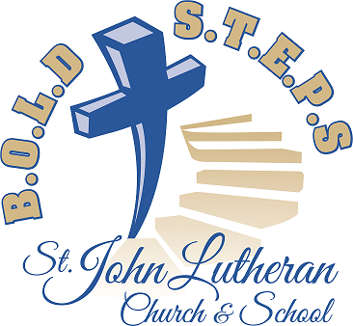When your B.O.L.D. S.T.E.P.S. Communication Committee began what is now a fairly long series of News Releases (13 over the past 16 months), we intended to introduce you to each of the four B.O.L.D. S.T.E.P.S. committees which are assisting you, the members of St. John, in some aspect of the large and complex task of bringing about the construction of new church and school facilities to better equip us for the Gospel ministry to which we have been called. Early releases introduced you to two of our hard-working committees, the Communication Committee and the Finance Committee. Now it is time to introduce you to the committee with the most obvious task: the Building Committee. This committee is responsible for the following:
- Selecting an architect and builder
- Developing building and site plans
- Revising plans as needed to match funding realities
- Overseeing the construction process
At various checkpoints along the way, the Building Committee intends to secure the approval of the congregation.

MEET YOUR BUILDING COMMITTEE:

Chair Ken Lemke has a history going back quite a ways here at St. John. He married Charlene (Char) Maass here at St. John several years before the additions to the front and back of the church were built – 42 years ago to be exact. Char's history at St. John goes back even farther – she attended St. John's elementary school for eight years back in the day when the building was not all that old! Ken and Char's three children (Chris, Ryan, and Jamie) were baptized at St. John and also attended our school. Currently some of their grandchildren are enrolled.

Now that Ken (and Char) are retired, he has more time to engage in his many hobbies: boating, fishing, turkey and deer hunting (both gun and bow), snowmobiling, and four-wheeling. In his spare time he chairs the Building Committee!
Gary Brandt has not lived in Wrightstown all his life – just most of it, having moved here in 1961. Three years later he graduated from our St. John Lutheran School and then from FVL in 1968. For 20 years he was employed by the Brillion Iron Works, after which he worked in sales and other positions for 27 years for a Chicago firm while maintaining his home here in Wrightstown. During his working years he held a variety of offices in various clubs and organizations, including a 4-year stint on the Village of Wrightstown board. Fully retired since 2016, he now serves as congregation president. With Jean, his wife of nearly 27 years, he enjoys traveling and membership in the Corvette Club (one red, one black). In addition, he hunts and fishes. A little known secret: Years ago he was known to frequent establishments with psychedelic lights and an open mic, at which he would read poetry he had composed, and even taught poetry classes at WHS!

Ron “Butch” Van Schyndel has for 34 years been married to his high school sweetheart Brenda. The Van Schyndels live in Kaukauna, and have been blessed with four children, all boys: Nick, full-time in the Army Reserves; Matt, employed by the city of Appleton; Jon, a police officer in Menasha; and Jacob, whom our Lord called home after a long battle with cancer. Butch owns his own business, Butch's Curb and Landscaping. If not improving someone's yard, you will find him quietly fishing or making noise on his motorcycle.
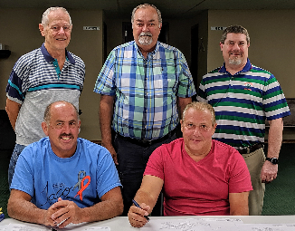
Ron Zahn's bio appeared in News Release #2 (December 2018). You will find it there – or ask him. He always has something to say.

(Release # 14 January 2020)

When your B.O.L.D. S.T.E.P.S. Communication Committee began what is now a fairly long series of News Releases (13 over the past 16 months), we intended to introduce you to each of the four B.O.L.D. S.T.E.P.S. committees which are assisting you, the members of St. John, in some aspect of the large and complex task of bringing about the construction of new church and school facilities to better equip us for the Gospel ministry to which we have been called. Early releases introduced you to two of our hard-working committees, the Communication Committee and the Finance Committee. Now it is time to introduce you to the committee with the most obvious task: the Building Committee. This committee is responsible for the following:
- Selecting an architect and builder
- Developing building and site plans
- Revising plans as needed to match funding realities
- Overseeing the construction process
At various checkpoints along the way, the Building Committee intends to secure the approval of the congregation.

MEET YOUR BUILDING COMMITTEE:

Chair Ken Lemke has a history going back quite a ways here at St. John. He married Charlene (Char) Maass here at St. John several years before the additions to the front and back of the church were built – 42 years ago to be exact. Char's history at St. John goes back even farther – she attended St. John's elementary school for eight years back in the day when the building was not all that old! Ken and Char's three children (Chris, Ryan, and Jamie) were baptized at St. John and also attended our school. Currently some of their grandchildren are enrolled.

Now that Ken (and Char) are retired, he has more time to engage in his many hobbies: boating, fishing, turkey and deer hunting (both gun and bow), snowmobiling, and four-wheeling. In his spare time he chairs the Building Committee!
Gary Brandt has not lived in Wrightstown all his life – just most of it, having moved here in 1961. Three years later he graduated from our St. John Lutheran School and then from FVL in 1968. For 20 years he was employed by the Brillion Iron Works, after which he worked in sales and other positions for 27 years for a Chicago firm while maintaining his home here in Wrightstown. During his working years he held a variety of offices in various clubs and organizations, including a 4-year stint on the Village of Wrightstown board. Fully retired since 2016, he now serves as congregation president. With Jean, his wife of nearly 27 years, he enjoys traveling and membership in the Corvette Club (one red, one black). In addition, he hunts and fishes. A little known secret: Years ago he was known to frequent establishments with psychedelic lights and an open mic, at which he would read poetry he had composed, and even taught poetry classes at WHS!

Ron “Butch” Van Schyndel has for 34 years been married to his high school sweetheart Brenda. The Van Schyndels live in Kaukauna, and have been blessed with four children, all boys: Nick, full-time in the Army Reserves; Matt, employed by the city of Appleton; Jon, a police officer in Menasha; and Jacob, whom our Lord called home after a long battle with cancer. Butch owns his own business, Butch's Curb and Landscaping. If not improving someone's yard, you will find him quietly fishing or making noise on his motorcycle.
Ron Zahn's bio appeared in News Release #2 (December 2018). You will find it there – or ask him. He always has something to say.

(Release # 14 January 2020)

