History of St. John Lutheran Elementary School
St. John Evangelical Lutheran Day School had its beginning in 1871 but was seemingly never an institution supported by the congregation. This situation remained until 1910 when the school was completely dropped. During this time, the responsibility of teaching fell upon the pastor’s shoulders. The pastor either conducted the classes himself or paid someone else to teach.
That early school had the dual purpose of teaching spiritual values in accordance with Lutheran doctrine as well as preserving German language and culture. As the immigrants and their children became more Americanized and the German heritage dimmed, the burden of providing secular education proved too great and children were sent to public school.
The conviction for the reestablishment of the Christian Day School had its beginnings in 1940. The congregation saw the fruits of Satan in its midst, which the lack of Christian Education had fostered. It became apparent that the former system of training its youth was grossly inadequate to equip future members for the desperate battle against devil, world, and flesh which each Christian must wage until our Savior calls us to our eternal rest.
With this knowledge, St. John congregation established a six-week Summer School Program in 1940. While this was only a make-shift alternative, as compared to the Christian Day School, it was nevertheless an admission of the need for more intensive religious

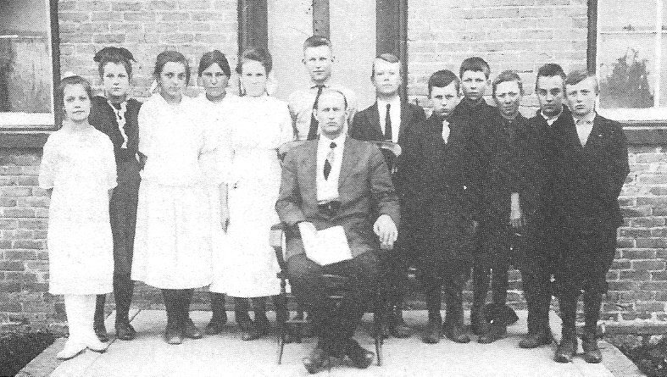

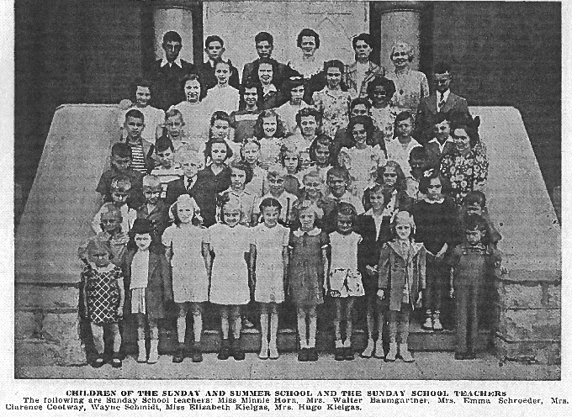
education for the congregation’s children and was certainly of inestimable benefit to all those who attended.
It was at this time, Pastor Gehardt Struck began to point out to the people the great need and value of a Christian Day School. He did this in two sermons entitled, respectively, “The Case for The Christian Day School, What Is it?” and “The Case Against the Christian Day School, What Is It?” (See end of this article for a reprint of an article from the Church Tidings by Pastor Henry E. Pussehl entitled “What is a Christian Day School? Why is it so important? Why do we have one?”)
With these admonitions in mind the congregation met on March 4, 1945 and decided by a vote of 48 to 17 “To investigate the possibility of establishing a Christian Day School in this congregation.” Upon this decision, a committee was formed.
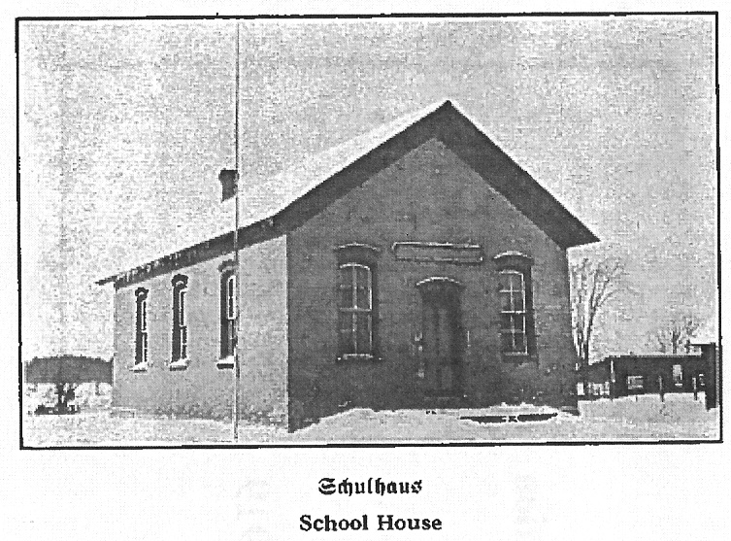
This committee brought its findings to the congregation at a special meeting held on May 13, 1945. A canvass of the congregation showed that 48 students would be sent to the school, if the congregation established one. The committee then recommended that the congregation start a Christian Day School. It was decided that the old school building, having by this time attained the venerable age of about 70 years, would still be suitable after slight repairs were made.
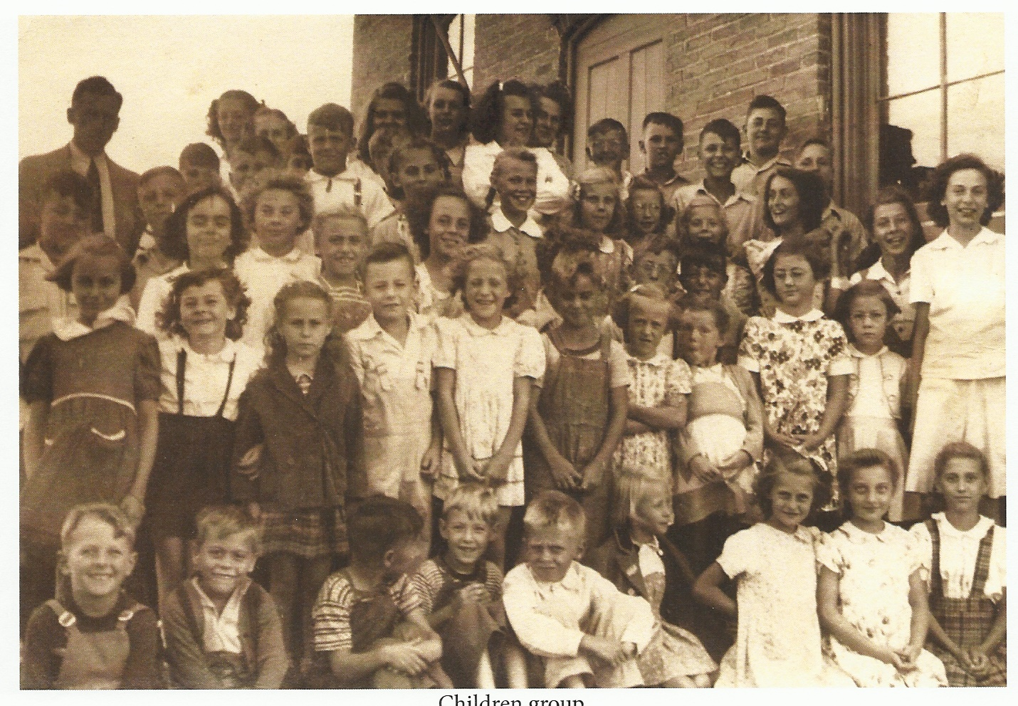
The Lord answered our call by sending Mr. Gerhard Koepsell of Manitowoc, Route 2, (Newtonburgh) to be the first teacher. Mr. Koepsell was a graduate of Dr. Martin Lutheran College at New Ulm, Minnesota. After a considerable amount of work and preparation, unstintingly and cheerfully donated by friends and supporters of the new venture, the new school opened its doors on September 4, 1945. What a day it was! From all directions came freshly scrubbed and neatly dressed children, most of them to attend a school of this kind for the first time in their lives. 48 children had been promised, but when all arrived, the count was 53. For a while, pastor and teacher were wondering where to find room for such a large group in a space that measured but 36 x 24 feet.

As to be expected this large enrollment soon brought forth the conviction that the room was entirely inadequate for this large student body. It was also emphasized that the teacher’s burden was greatly increased because these students composed grades 1 through 8.
At a meeting on January 27, 1946, the question of a new school building came up for discussion. This committee found that rebuilding the old school was hardly advisable, because of its decrepit state and the inadequacy of the site for a good playground. Since the acquisition of new property adjacent to the site was well out of the question, it was considered most advisable to relocate the school. The present site was recommended by a majority of the committee. In making their choice of location, this committee was also influenced by the safety factor. The new building would be situated on a quiet side street with little traffic. The possibility of children being hurt would thus be minimized. The committee recommended that land be purchased, and an entirely new building be erected.
At the same time, a call went out for an extra teacher. The congregation decided on an ex-teacher until a graduate of Dr. Martin Luther College could be sent. Mrs. Melvin Croll (wife of the Greenleaf Pastor) accepted this call for the school year 1946-1947. Because of the lack of facilities both Mr. Koepsell and Mrs. Croll taught in the same room. To say the least these were not very advantageous conditions.
In 1947 the Lord assigned Miss Elaine Rademann, a graduate of Dr. Martin Luther College, New Ulm, Minnesota, to teach in our school. Miss Rademann was assigned the use of the old school building while Mr. Koepsell conducted his classes in the basement of the church.
Other complications that entered the picture were the fact that a new building always involves a considerable outlay of money; that America was at that time in the throes of “reconversion”, with its attendant material shortages, after having finished World War II; that a new building would call for relocation; and that having built a new building, we might not even be able to secure an extra teacher, since there was a shortage of teachers at that time.
It should also be mentioned about this time the congregation bought the old American Hotel which had to be razed because of a highway relocation. Many members came to help dismantle the building. The investment proved a sound one, as the bricks and other materials salvaged were then used to build the new school.
At a meeting on July 14, 1946, preliminary plans for a new school building were drawn up by Edgar A. Stubenrauch of Sheboygan and adopted. The congregation had to apply to the Civilian Production Administration for permission to construct a new school building. This request was at first denied by the C.P.A.
It was plain to see that such conditions could not continue indefinitely. A determined effort was to be made to increase the school building fund, and another application was to be made to the C.P.A. for a construction permit.
By March 28, 1947, things had progressed so far that plans for a new school were unanimously adopted. In the regular quarterly meeting of July 6, 1947, Mr. Koepsell read a condensed report of the bids received for the construction of the new school.
It would be futile to deny the decision to go ahead with the project had hardly become a firm one in the minds of most members by this time. There was much weakness, much doubt, much uncertainty, and much lack of conviction. However, in a special meeting held in the old schoolhouse on the evening of July 14, 1947, the momentous decision was finally made. The congregation voted to go ahead with the building of the school.
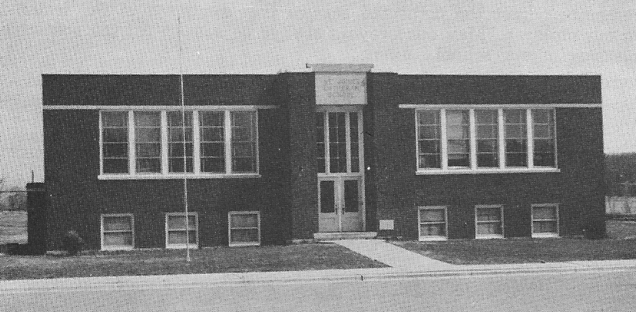
Actual breaking of the ground occurred on August 4, 1947. Cornerstone laying ceremonies were held in an afternoon service on October 12, 1947. Pastor L.H. Koeninger of Manitowoc delivered the sermon. The school children offered appropriate hymns. On August 29, 1948, during a morning worship service, Pastor A. Koelpin of Caledonia, Wisconsin gave the sermon. A procession to the new school building was done and then they had a Door Opening Ceremony in which the present school building was dedicated to the glory of God in the training of his lambs.
In 1952 the Lord summoned to his eternal home the soul of Mr. Gerhard Koepsell. For the remainder of the school term, students of Wisconsin Lutheran Seminary and Dr. Martin Luther College acted as instructors.
On the thirteenth Sunday after Trinity, August 31st, 1958, the church celebrated the 10th anniversary of their school. A special dedication divine morning service was arranged with Pastor Gerhard Struck of Dowagiac, Michigan. Then an afternoon divine worship service was arranged with Dr. Elmer Kiessling of Northwestern College, Watertown, WI, as the guest preacher.
As early as 1959 the need for a third teacher was discussed. This was due to an increase in enrollment. In 1963 the congregation authorized the calling of a third teacher. Since that time the grades had been divided according to the following schedule: 1st and 2nd, 3rd through 5th, and 6th through 8th occupied separate rooms. A new sidewalk was also installed by members in the front of the school during this school term.
In 1954 a kindergarten class was initiated. This preschool program has been in effect since its inception.
On November 6, 1969 sad news reached this congregation. Our former teacher Mr. James Enter, was called to the bosom of our Savior to enjoy eternal bliss.
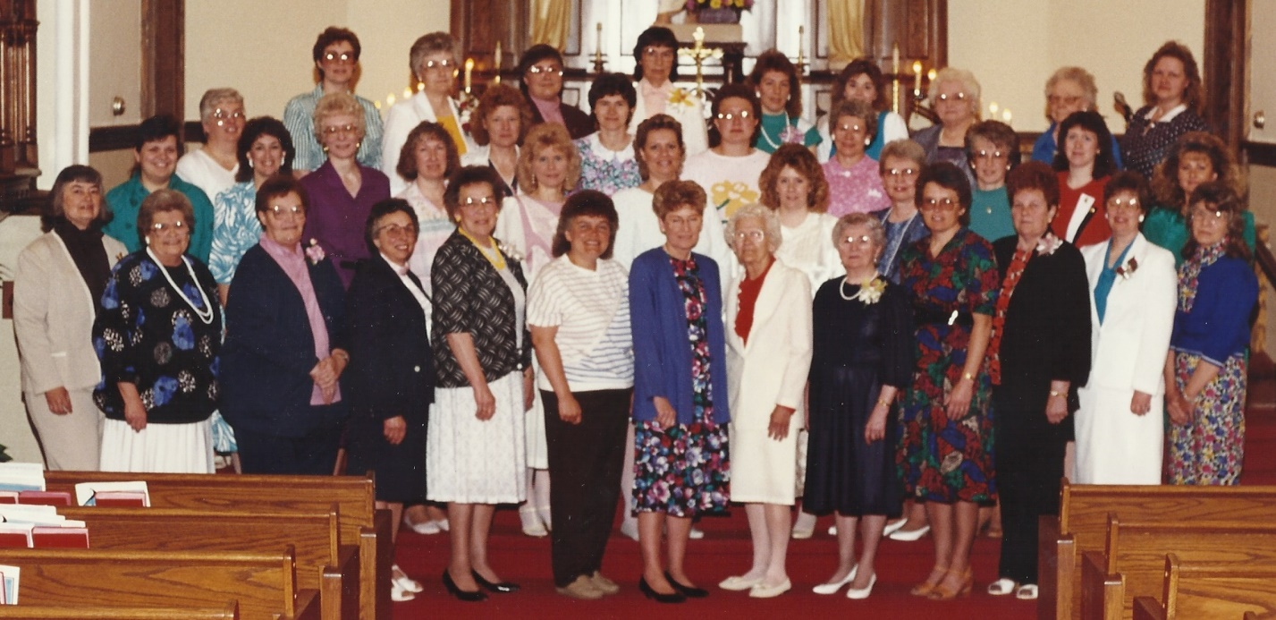
On April 28, 1996, the congregation celebrated the fiftieth anniversary of the 1946 decision to build a new Christian Day School. Pastor Gerhard Schopekahm was guest preacher and Pastor Carl Klein was liturgist. The school children directed by Thomas Schroer, sang “One Life Touches Another” and an alumni choir, directed by Florence Brandt, sang “Amazing Grace.”
A historical video, entitled “Let the Children Come,” was produced and shown to a large audience. This video recounted the history of the Christian Day School from 1946 to 1996 and included many interviews with former teachers and students.
In 2013 the preschool program was expanded to offer both full time and part time education for both PK3 and PK4, under the leadership of the Board of Christian Education. Voters approved an enrollment plan for the school. The interior of the school and outside grounds was improved.
May all our former teachers be remembered for the dedicated service they rendered in the training of our children. May our prayers always be spoken for the continual blessing of our school.

List of LES School Principals and Teachers

Principals:
Gerhard Koepsell 1945-1952
George Lillegard 1952-1957
Gerhard Schopekahm 1957-1959
Merlin Putz 1959-1961
James Enter 1961-1968
Alan Draeger 1968-1974
David Allerheiligen 1974-1981
Harold Runke 1981-1993
Lawrence Lotito 1993-2002
Ronald Zahn 2002-2006
Jason Williams 2006-2009
Jason Hagenow 2009-2014
Tim Raddatz 2014 to present

Teachers:
Gerhard Koepsell 1945-1952
Edna Croll 1946-1947
Elaine Rademann 1947-1950
Leonardo Vogel 1950-1951
Lois Miller 1951-1952
George Lilligard 1952-1957
Marjorie Mumm 1952-1954
Gerhard Schopekahm 1954-1959
Lois Schopekahm 1956-1958
Marilyn Engnes 1958-1961
Merlin Putz 1959-1961
Bernice Pussehl 1960-1962
Ester Roebke 1960 (part time)
James Enter 1961-1968
Mary Funk 1962-1963
Marilyn Wierschke 1962-1963
Wally Flegel 1962-1968
Karen Jenkins 1963-1968
Susan Schroeder 1964-1965
Joyce Timm 1965-1971
Alan Draeger 1968-1974
Roseanne Draeger 1968-1969
Barbara Schendel 1969-1971
Elaine Kittel 1971-1973
Virginia Frey 1971-1972
Janet Barthel 1972-1973
Shirley Dast 1972-1978
Mary Gosse 1973-1976
Sheryl Gabower 1973-1974
David Allerheiligen 1974-1981
Rita Allerheiligen 1975-1977
Joslyn Wichmann 1976-1977
Marilyn Wierschke 1977-1979
Mary Sue Pluess 1977-1987
Thomas Schroer 1978-1998
Kristina Ungemach 1979-1981
Harold Runke 1981-1993
Eleanor Runke 1982-1987
Judy Anderson 1987-?
Pamela Peper ? - ?
Eleanor Runke 1988-1993
Lawrence Lotito 1993-2002
Diane Wiernicke 1998-1999
Katherine Lotito 1993-2002
Rebecca Lueddecke 1999-2002
Trisha (nee Feder) Vickman
1996-2001
Lora Dufore 2002-2004
Elizabeth Vetting 2002-2004
Ron Zahn 2002-2006
Sarah Williams 2004-2009
Jason Williams 2004-2009
Jason Hagenow 2009-2014
Marti Ellingboe 2006-2013
Amanda Prickett 2006-2011
Jennifer Bunn 2001 to present
Rebecca Wicks 2011 to present
Tim Raddatz 2014 to present
Jamie Buss 2015 to present
Alexa Foelske 2018 to present

“What is a Christian Day School? Why is it so important? Why do we have one?
By Pastor Henry E. Pussehl

Where a Christian Day School already exists and is in operation such questions should no longer arise. Yet they do! In one sense that can be said to be unfortunate: in another fortunate. It can be called unfortunate in the sense, that the answers to these questions are not known by one and all. It can be called fortunate in the sense, that asking of the questions indicates the unknowing ones have not fully closed their minds and hearts to the importance and need of such a school.
A Christian Day School is a school established and maintained by the Christian Church to instruct children in the soul-saving Word of God, and in the secular branches of learning in the light of the eternal Word, through the medium of trained Christian teachers. Christian parents want to provide a wholesome, Christ-centered atmosphere for their children in their own homes. They know how important this is in the lives of their children. But Christian parents also know it is equally important to have their children under the influence of a Christian atmosphere during the hours their children are in school, for those hours make up about one third of the twenty-four-hour day. And where can they find that for their children but there where Christ is the center of all living, all teaching, and all learning – the Christian Day School?
But why are Christian parents so concerned about that? Because they know the children really belong to the Lord and are only entrusted to the care of the parents by the Lord for a period of time. During this time, they are to be nurtured, educated, and trained for the Lord that they might be returned to the Lord for His use and service in His kingdom here, and for His everlasting enjoyment of their presence with Him hereafter. The great poet John Milton understood that, for he wrote, “The end of all education is for the child to gain the knowledge of god in Christ, and out of that knowledge to love Him, to imitate Him, and to grow like Him.” That objective can, under the blessings of God, be attained in no better way than through the means of a Christ-centered day school.
Blessed are they who have a Christian Day School and use it.”

