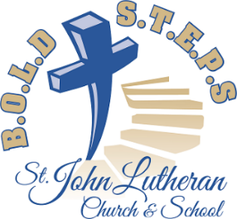
ORGAN TRANSPLANT FORUM

Sunday, October 27, at 11:30 a.m.

Yes, things are getting more than busy in regard to the B.O.L.D S.T.E.P.S building project, and they are even busier for the several committees at work to bring this project to fruition.

Since questions have arisen regarding the organ, whether or not we should take it with us to the new church, it seemed wise to engage in an informative discussion regarding organs and Lutheran worship. Our organ consultant, Doctor Wayne Wagner, retired from the music staff at Martin Luther College, will be present to lead the discussion. He will bring with him a wealth of experience and information.

Even if you have no thoughts to share, come to be enriched by the discussion covering such topics as...
- Why use an organ at all in a 21st century Lutheran worship service?
- Is a 100-year-old organ worth taking to a new church?
- If the organ is worth keeping, what would it cost to take it to the new church?
- What other options exist?
- What else related to the organ needs to be considered?
PLEASE PLAN TO ATTEND!
( #10 October 2019)
ORGAN TRANSPLANT FORUM

Sunday, October 27, at 11:30 a.m.

Yes, things are getting more than busy in regard to the B.O.L.D S.T.E.P.S building project, and they are even busier for the several committees at work to bring this project to fruition.

Since questions have arisen regarding the organ, whether or not we should take it with us to the new church, it seemed wise to engage in an informative discussion regarding organs and Lutheran worship. Our organ consultant, Doctor Wayne Wagner, retired from the music staff at Martin Luther College, will be present to lead the discussion. He will bring with him a wealth of experience and information.

Even if you have no thoughts to share, come to be enriched by the discussion covering such topics as...
- Why use an organ at all in a 21st century Lutheran worship service?
- Is a 100-year-old organ worth taking to a new church?
- If the organ is worth keeping, what would it cost to take it to the new church?
- What other options exist?
- What else related to the organ needs to be considered?
PLEASE PLAN TO ATTEND!
( #10 October 2019)

